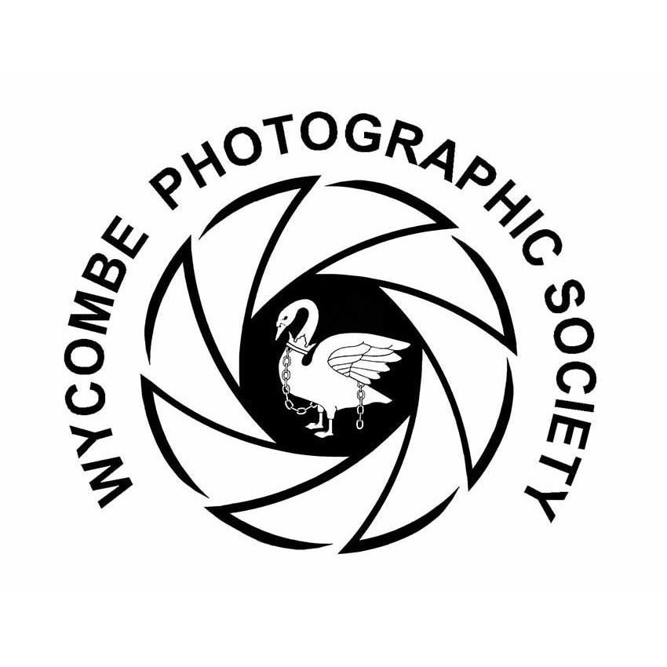
Wycombe Photographic Society
Annual Exhibition
Entry Form
PROJECTED IMAGES – DPIs

DPIs may be entered in the following sections

Candid | CAN
Creative | CRE
Cultivated flowers/plants | FLO
Foreign Travel | FT
Landscape | LAN
People & Portraits | P-P
Pictorial | PIC
Wildlife | WIL

Note: Wildlife covers Natural History – but NOT garden flowers or domestic animals
Note: Foreign Travel excludes anywhere in the United Kingdom and Eire

AUTHORS NAME:____________________________________________________

CLASS:____________________________________________________

EXHIBITION YEAR:____________________________________________________

DPI | Title | Section code
1
2
3
4
5
6
7
8

